SUB-SYSTEM | Employee Master
USER | Mr. Mofizuddin Ahmed
ANALYST | Shameem Ferdous
Date / Time | 25/06/2003 11:00am

1 DESCRIPTION

This module enables National Medical Institute Hospital to keep track of its employee information. Employee’s information consists of :
- Employee personal information
- Employee salary information
- Job information
- Employee Address

Information of any particular employees can be retrieved in any prescribed format.

This module keeps basic information of the employees which are required for tracking employees attendance, leave, loan, salary advance etc. and farther allows the user to prepare monthly salary, overtime, festival bonus etc.

2 PROCESS FLOW - CURRENT

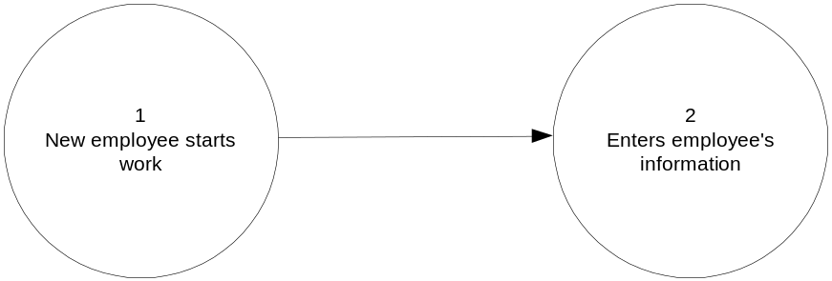

3 NEW PROCESS FLOW

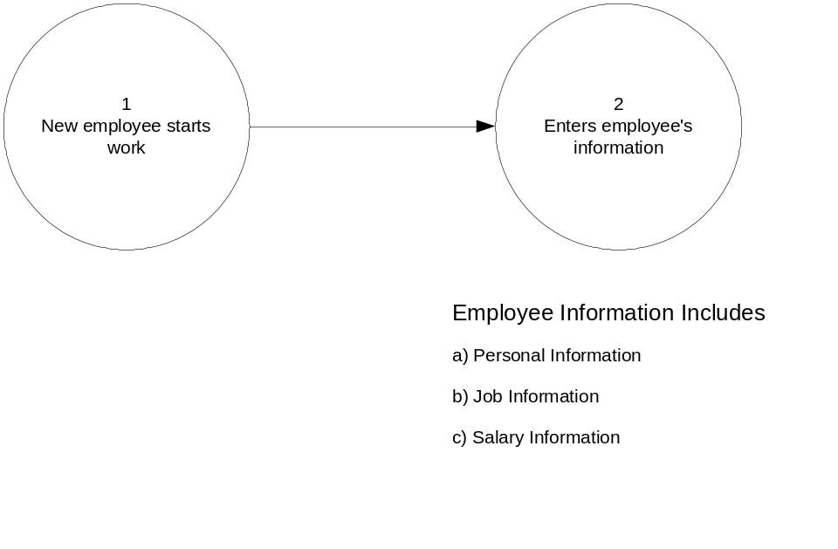
4 USER REQUIREMENT

- Employee Master Information
- 4 different class types:
  - A – Class 1
  - B – Class 2
  - C – Class 3
  - D – Class 4
- Employee ID (e.g. A-001) should consists of the following:
  - Class Type – A
  - Serial number – 001
- Name should consists of the following:
  - First Name
  - Middle Name
  - Last Name
- Address should consists of the following:
  - House/Street
  - City/Town/Village
  - Zip/Post Code
  - Country
- Sex can either be:
  - Male
  - Female
- Marital status can either be:
  - Single
  - Married
- Address information:
  - Current Address
  - Permanent Address

- Telephone information:
  - Home Telephone
  - Mobile Telephone
- Telephone information should consist of the following:
  - Telephone/Fax number must consist of <area code or operator code> <phone/fax number> (Currently, phone consists of 7 digits. E.g. 02-1234567)
- For employee classified under class 1 and class 2, the following attributes are required :

- For employee classified under class 3 and class 4, the following attributes are required :
  - Visible distinguish mark
- Date of Birth should be in dd-mm-yyyy format
- Employee must be within a certain age range upon joining National Medial Hospital (currently employment age must not be younger than 18 and not older than 30 years old)
- The retirement date should be calculated automatically based on the standard government retirement age (currently, retirement age is at 57 years old)

- Pay scale determines an employee’s basic salary (Currently, there are 20 different types of pay scale. For more information, please refer to Appendix A)
- Employee is required to contribute a standard percentage of salary to provident fund (currently, the percentage is at 10%)
  - Area code – 44403000111
  - Sex:
    - Male – 1
    - Female – 2
  - Serial number - 0144
- There is no standard provident fund account number format and the provident fund account number is provided by Accountant General (AG) office.

5 CONCEPT – SYSTEM
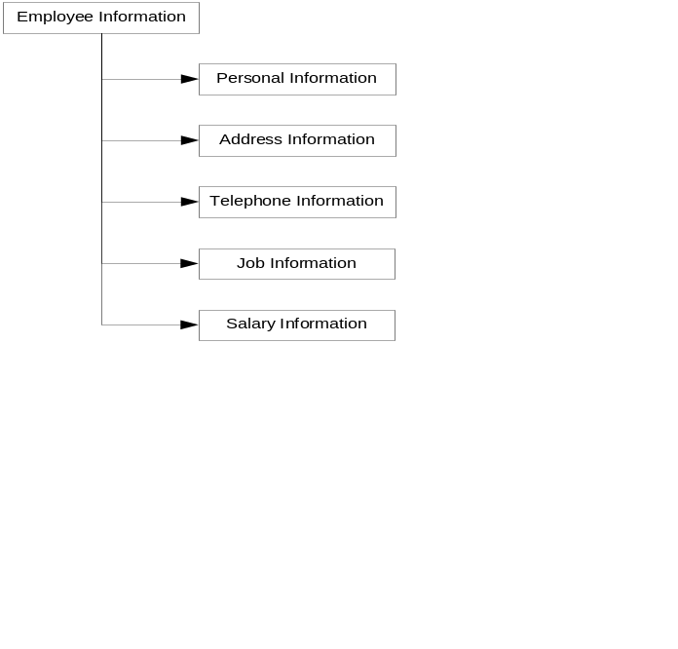

6 COMMENT

The pay formula is as below :
Salary = (Basic Pay) + (Increment Rate X Number of Increment)
+ (Efficiency Bar X Number of Times of Efficiency Bar)
For example, in Pay Scale 9, its Pay Scale Description is 2375-150X7-3425-EB-155X11-5130 which :
- Basic pay is 2375
- Increment Rate is 150
- Number of Increment is 7
- Efficiency Bar (EB) is 155
- Number of Times of Efficient Bar (EB) is 11
- Final pay is 5130
(For more information, please refer to Appendix A)

7 ACCESS RIGHT

Application Manager: Read, Write & Delete
Data Entry: Read & Write
Other: Read Only

No. of Users expected to access the database :

- Application Manager :
- Data Entry :
- Other :

8 INFORMATION CHECKLIST

No. | Sample Formats | Received from BRTA | Notes | Our Ref.
01 | Sample Copy of Pay Scale | Yes |  | EM01

9 ATTRIBUTES

1 | Human Resource Information System | Information Type: | Employee Information
No. | Attribute Name | Type | Size (bytes) | Description
1 | Employee Id | Char |  | Employee Id (e.g. A-001)
2 | Employee’s First Name | Char |  | Employee’s First Name
3 | Employee’s Middle Name | Char |  | Employee’s Middle Name
4 | Employee’s Last Name | Char |  | Employee’s Last Name
5 | Father’s Name | Char |  | Father’s First Name
6 | Mother’s Name | Char |  | Mother’s First Name
6 | Gender | Char |  | Gender (To be chosen from combo box. E.g. Male or Female)
7 | Date of Birth | Date |  | Date of Birth (dd-MMM-yyyy)
8 | Marital Status | Char |  | Marital Status (To be chosen from combo box. E.g. Single or Married)
9 | Religion | Char |  | Religion (To be retrieved from combo. E.g. Muslim)
10 | Nationality | Char |  | Nationality (e.g. Bangladeshi)
11 | Provident Fund Account Number | Char |  | Provident Fund Account Number
12 |  | Char |  | Email Address (e.g. smonir@daffodil-bd.com)
18 | Photo | Image |  | Employee’s Photo

6 | Human Resource Information System | Information Type: | Employee Address Information (maximum of 2 records per employee)
No. | Attribute Name | Type | Size (bytes) | Description
1 | Street/House No. | Char |  | Street
2 | City/Town | Char |  | City/Town
3 | Postal Code | Number |  | Postal Code
4 | State | Char |  | State
5 | Country | Char |  | Country
6 | Address Type | Char |  | Address Type which consists of type:  - Current  - Permanent

9 | Human Resource Information System | Information  Type: | Job Information
No. | Attribute Name | Type | Size (bytes) | Description
1 | Designation | Char |  | Designation (To be retrieved from lookup table)
2 | Section | Char |  | Section (To be retrieved from lookup table)
3 | Department | Char |  | Department (To be retrieved from lookup table)
4 | Branch | Char |  | Branch (To be retrieved from lookup table)
5 | Report To | Char |  | Report to the immediate supervisor
6 | Date Joined | Date |  | Date Joined
7 | Retirement Date | Date |  | Retirement Date to be calculated automatically
8 | Job Description | Char |  | Job Description
9 | Additional Responsibilities | Char |  | Additional Responsibilities
10 | Job Type | Char |  | Job Type (To be retrieved from lookup table) :  - Contract  - Temporary  - Permanent
10 | Human Resource Information System | Information  Type: | Physical Attribute Information
No. | Attribute Name | Type | Size (bytes) | Description
1 | Eye Sight | Char |  | Eye Sight (e.g. 20/20)
2 | Height | Number |  | Height (e.g. 1.6m)
3 | Weight | Number |  | Weight (e.g. 80kg)
4 | Disabilities | Char |  | Disabilities (e.g. blind, deaf)
5 | Blood Group | Char |  | Blood Group (e.g. A group)
6 | Visible Distinguished Mark | Char |  | Visible Distinguished Mark (e.g. birthmark, scar)

11 | Human Resource Information System | Information Type: | Employee Telephone Information (maximum of 4 records per employee)
No. | Attribute Name | Type | Size (bytes) | Description
1 | Telephone Number | Number |  | Telephone  Number (e.g. <area-code or operator code> 1234567)
2 | Phone Type | Char |  | Phone Type (To be retrieved from lookup table) which consists of type:  - Home Phone  - Office Phone  - Mobile Phone  - Fax

12 |  | Human Resource Information System |  | Information Type: |  | Pay Scale Information  (Maximum of 20 records)
No. | Attribute Name |  | Type |  | Size (bytes) |  | Description
1 | Pay Scale |  | Char |  |  |  | Pay Scale (To be retrieved from lookup table)
2 | Pay Scale Description |  | Char |  |  |  | Pay Scale Description (To be retrieved from lookup table)
3 | Basic Pay |  | Number |  |  |  | Current basic pay (e.g. 2500)
4 | Rate of Increment |  | Number |  |  |  | Rate of increment per year depending pay scale (e.g. 650)
5 | Number of Increment |  | Number |  |  |  | Number of increment (e.g. 4). Maximum number of increment depends on the pay scale.
6 | Efficiency Bar (EB) Amount |  | Number |  |  |  | Efficiency Bar (EB) Amount
7 | Number of Times of Efficiency Bar (EB) |  | Number |  |  |  | Number of Times of Efficiency Bar (EB) (e.g. 11).  Maximum number of Efficiency Bar depends on the pay scale.

11 APPENDIX A

- Pay Scale Table (in Bengali)

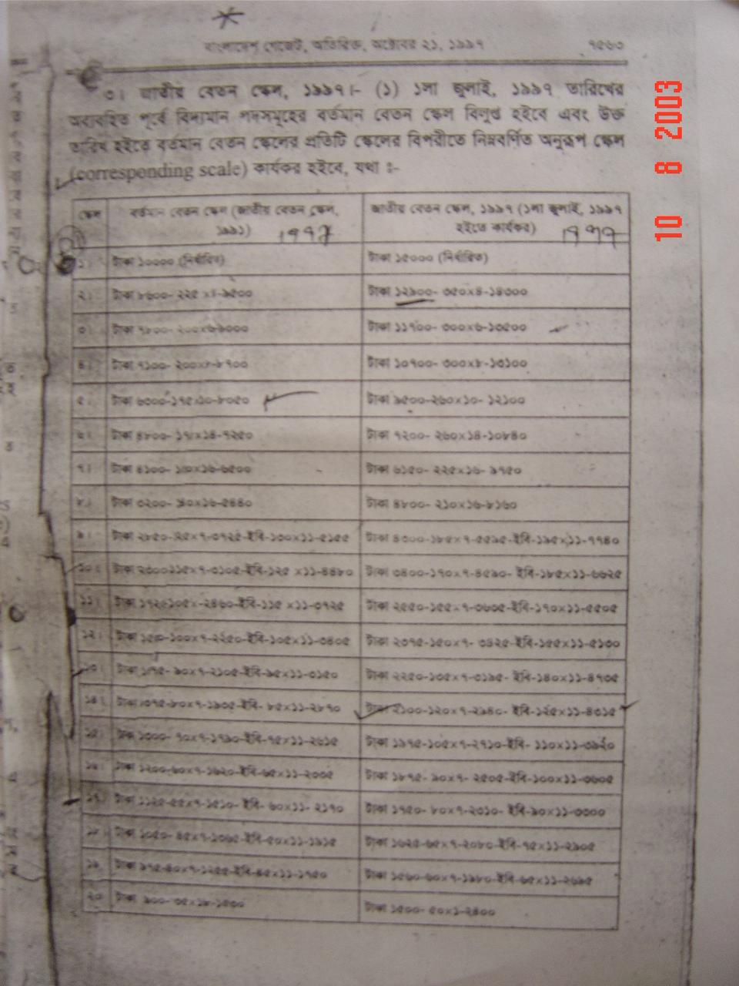
- Pay Scale Table (in English)

Pay Scale | Pay Scale Description (Year 1997)
1 | 15000 fixed
2 | 12900-350x4-14300
3 | 11700-300x6-13500
4 | 10700-300x8-13100
5 | 9500-260x10-12100
6 | 7200-260x14-10840
7 | 6150-225x16-9750
8 | 4800-210x16-8160
9 | 4300-185x7-5595-EB-195X11-7740
10 | 3400-170X7-4590-EB-185X11-6625
11 | 2550-155X7-3635-EB-170X11-5505
12 | 2375-150X7-3425-EB-155X11-5130
13 | 2250-135X7-3195-EB-140X11-4735
14 | 2100-120X7-2940-EB-125X11-4315
15 | 1975-105X7-2710-EB-110X11-3920
16 | 1875-907-2505-EB-100X11-3605
17 | 1750-80X7-2310-EB-90X11-3300
18 | 1625-65X7-2080-EB-75X11-2905
19 | 1560-60X7-1980-EB-65X11-2695
20 | 1500-50X1-2400

